COMMON LINUX COMMANDS

**1.ls command**

– List information about the files(the current directory by default).

ls syntax:ls [option][file/dir]

Some of ls command options:

-a = list all files including hidden file starting with ‘.’

-d = list directories - with ‘*/’

-l = list with long format – show permissions

-r = list in reverse order

-s = list file size

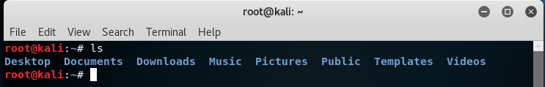

**2.cd command**

-change the current directory to DIR.The default DIR is the value of the HOME shell variable.

cd syntax: cd [directory]

Some of ls command options:

cd = will change to home directory

cd / = will change to root directory

cd .. = will change to parent directory

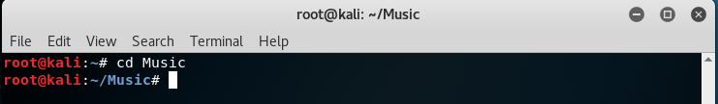

**3.mv command**

-Rename source to dest,or move source to directory.

mv syntax: mv [options] source destination

mv command options:

-f = force move by overwriting destination file without prompt

-i = interactive prompt before overwrite

-u = update-move when source is newer than destination

-v = verbose-print source and destination files

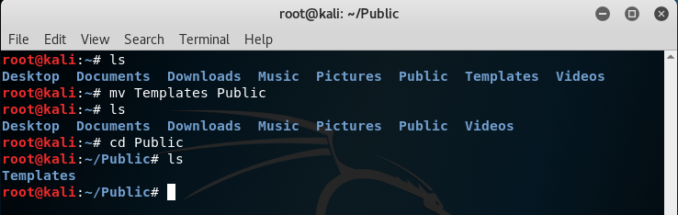

**4.rm command**

-remove (unlink) the file

rm syntax: rm [options] file

Some of rm command options:

-f, --force = ignore non-existent files, never prompt

-i = prompt before every removal

-v, --verbose = explain what is being done

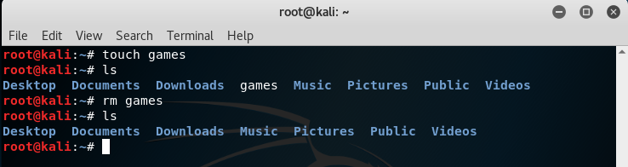

**5.mkdir/rmdir command**

mkdir-Create the directory,if they do not already exist

rmdir-remove the directory,if they are empty.

rmdir syntax: mkdir filename

rmdir filename

Some of mkdir/rmdir command options:

-m = set file mode (as in chmod). (only for mkdir)

-p = mkdir-no error if existing, make parent directories as needed

rmdir-remove directory and its ancestors

-v = mkdir-print a message for each created directory

rmdir-output a diagnostic for every directory processed

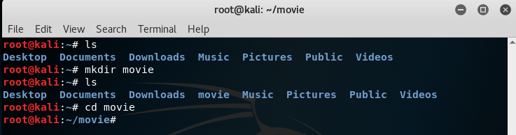

**6.touch command**

-A command that change file timestamps.

touch syntax: touch [option] file

Some of touch command options:

-a = change only the access time

-c = do not create any files

-d = parse STRING and use it instead of current time

-m = change only the modification time

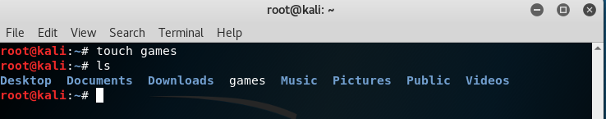

**7.cat command**.

-cat used to display the content of text files and to combine several files to one file.

Note: this command does not accept directories.

cat syntax: cat [options] file1 file2…..

Some of cat command options:

-b = add line numbers to non-blank lines

-n = add line numbers to all lines

-E = show $ at the end of line

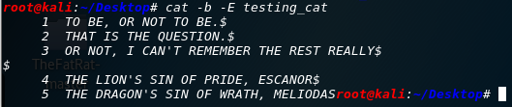

**8.pwd command**

-Command used to print working directory, a Linux command to get the current working directory.

pwd syntax: pwd [option] (option is not necessary)

Some of pwd command options:

-h = display a brief help message and exit

-V = display version information and exit

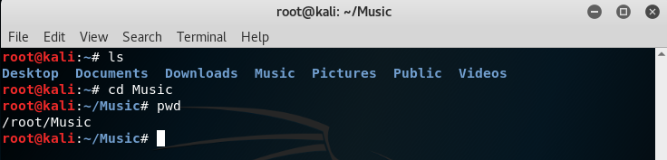

**9.file command**

-Used to determine file type.

file syntax: file [options] [-f namefile] [-F separator] [-m magicfiles]…….

Some of file command options:

-f = read the names of the files to be examined from namefile

-F = use the specified string as the separator between the filename and the file result returned. Defaults to “:”

-m = specify an alternate list of files containing magic numbers.

-b = do not prepend filenames to output lines (brief mode)

-N = don’t pad filenames so that they align in the output

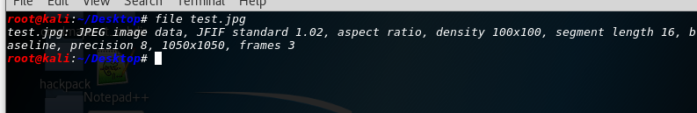

**10.ln ommand**

-Will make links between files.

ln syntax: ln [option] target (the simplest syntax form)

Some of ln command options:

--backup = make a backup of each existing destination file

-b = like –backup but does not accept an argument

-f = remove existing destination files

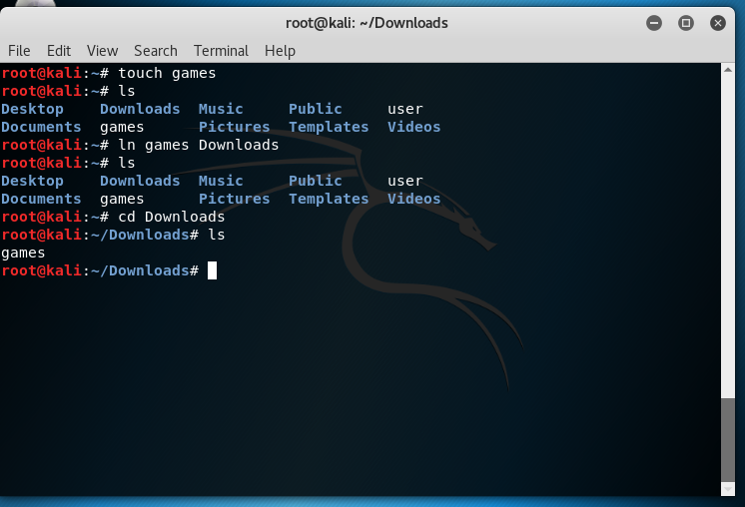

**11. chmod/chown command.**

chmod = to change access permissions, change mode.

chown = to change owner, change the user and/or group ownership of each given file to a new owner.

The syntax: chmod [options] Numeric_Mode file

chown [options] NewOwner file

Some of chmod/chown command options:

-f = chmod-supress most error messages

chown-do not print error messages about files whose ownership cannot be changed

-v = chmod-output a diagnostic for every file processed

chown-verbosely describe the action (or non-action) taken for every file.

-c = chmod-like verbose but report only when a change is made

chown-verbosely describe the action for each file whose ownership actually changes

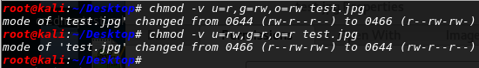

**12. more/less command.**

more = to view a text file one page at a time, press spacebar to go to the next page.

less = almost the same as more command with some exception:

1. can navigate the page up/down using less command, not possible in more command.
2. can search a string in less command.
3. more was fairly limited and any additional development has stopped.

The syntax: more [option] [-num] filename

less [option] filename (simplest form)

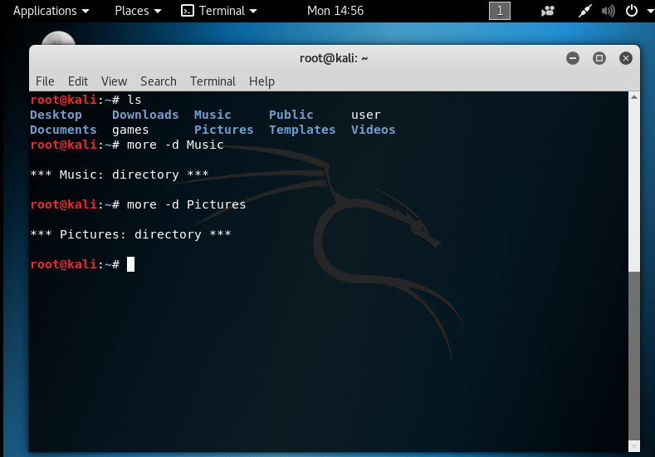

**13. grep command.**

It is use to print lines matching a pattern.

grep syntax: grep [option] pattern [file]

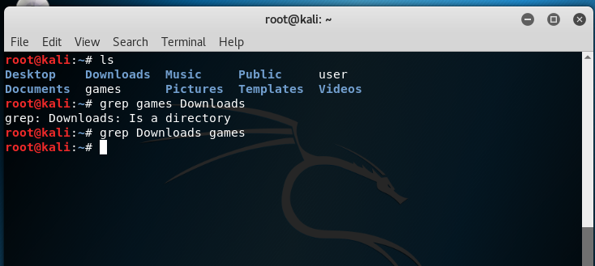

**14. wc command.**

Will print the number of newlines, words and bytes in files.

wc syntax: wc [option] file

wc command options:

-c = print the byte counts

-m = print the character counts

-l = print the newline counts

-w = print the word counts

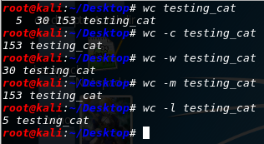

**15.kill command**

Used to terminate a process.

kill syntax: kill -l [signal] (simplest form)

Some of kill command options:

-l = prints a list of signal names

-s signal = specify the signal to send, it may be given as a name or number

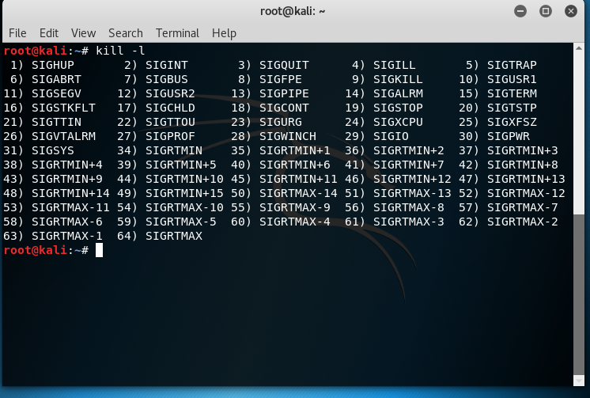

**16. ps command.**

Will provide information about the currently running processes.

ps syntax: ps [option]

Some of ps command options:

-d = select all processes except session leaders

-e = select all processes

-r = restrict the selection to only running processes

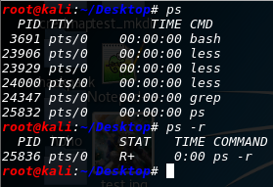

**17.top**

Used to display Linux task.

top syntax: top [option] (simplest form)

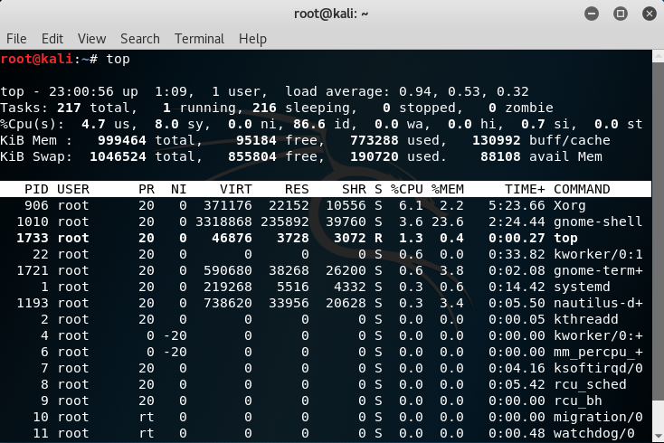

Some of top command options:

-b = starts top in ‘Batch Mode’

-n = specifies the maximum number of iterations, or frames, top should produce before ending

-M = show memory units (k/M/G) and display floating point values in the memory summary

**18. uname command.**

The command is use to print system information.

uname syntax: uname [option]

Some of uname command options:

-a = print all information in a default order, except omit -p and -i if unknown

-s = print the kernel name

-p = print the processor type or “unknown”

-i = print the hardware platform or “unknown”

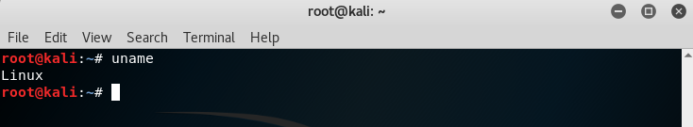

**19. uptime command.**

Will tell how long the system has been running.

uptime syntax: uptime [option] (option is not necessary)

Some of uptime command options:

-h = display a brief help message and exit

-V = display version information and exit

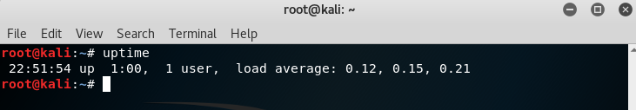

**20. ping command.**

Send ICMP ECHO_REQUEST packets to network hosts.

ping syntax: ping [option] [option] ….. destination

Note: the syntax can be insert with multiple kinds of option if need be.

Some of ping command options:

-a = audible ping

-b = allow pinging a broadcast address

-B = do not allow ping to change source address of probes. The address is bound to one selected when ping starts

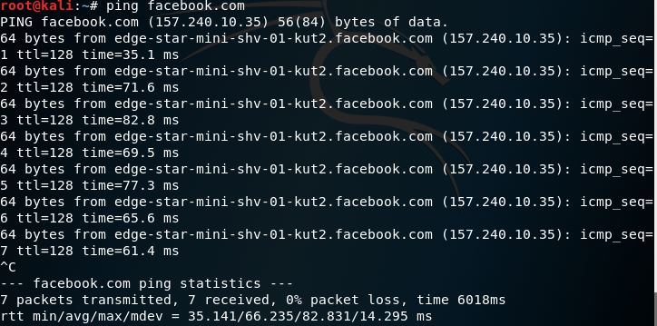

**21. netstat command.**

The command is use to print network connections, routing tables, interface statistics, masquerade connections and multicast memberships.

netstat syntax: netstat [option] [option] …..

Some of netstat command options:

(none) = by default, netstat displays a list of open sockets with all the configured address families of the active sockets

-g = display multicast group membership information for IPv4 and IPv6

-i = display a table of all network interfaces

-s = display summary statistics for each protocol

